Grata Content Marketing Handbook

Grata
Last edited：2013/7/18



Grata concierge is an advanced service platform that you can use to better serve your clientele and optimize your customer service.

Grata is our brand-new mobile application, designed to better deliver products to your clients, and creating a direct line of communication between you and your customers.

The following documentation describes how to best utilize Grata by updating your information in our server—using the finest available emerging content system to deliver for your customers.

1. Login to the System

On the Grata.com homepage login with your username by hovering your mouse over the “Admin” button on the top right corner. Select “Connect Admin” from the dropdown menu to access our server.
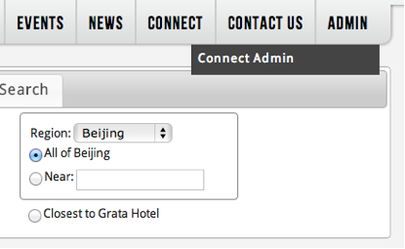
(Figure 1.1: Entryway to the content editor interface)
The page will jump to the screen below (as in Figure 1.2), and you can now begin updating your information.

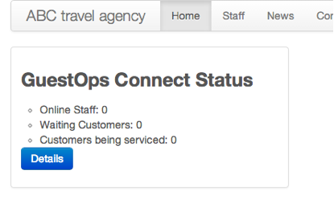
(Figure 1.2: The default content editor homepage)

Here the “ABC travel agency” we’ve provided is a fake company, used to outline the steps needed for installation.

As you can see above, this company’s interface currently shows how many mobile customers are awaiting service, how many customers are currently being served, and how many hotel staff members are online addressing customer needs. (Because this is a fake company, there are currently no customers and no concierge staff on duty.)

2. Edit Your Organizational Profile

We suggest you begin by editing your organizational profile, found in the last tab of the navigation bar. (See Figure 3)

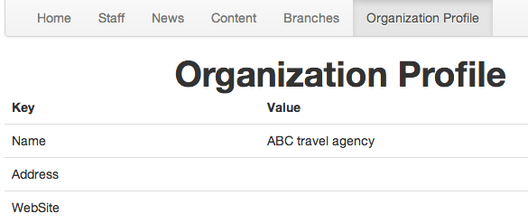
(Figure 2.1: The organization profile is the last tab on the navigation bar)

Click the “upload photo” button on the page, and upload a .png, .jpg, .jpeg, or .gif formatted image using the interface provided. Regardless of which format you use, we recommend the image be no larger than 540 x 300 pixels.

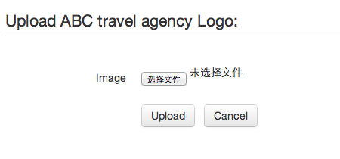
(Figure 2.2: Uploading a logo)

Upon successful upload, your logo should appear as in Figure 2.3 below:
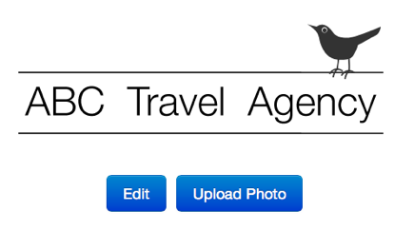
(Figure 2.3: After upload)

After uploading please fill out the following fields:
- Name
- Logo
- Address
- Telephone
- Domain
- Latitude and Longitude
- Website
- Email

To find your hotel’s (or desired location’s) coordinates, direct your browser to: https://maps.google.com/

Type in your address, then right click the location pointer that pops up. In the menu, select “What’s here?” Your latitude and longitude coordinates will appear in the search box.

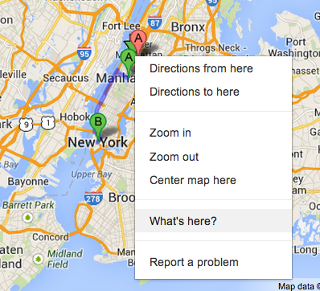

(Figure 2.4 shows an example of a filled out field)
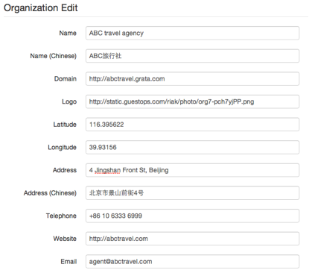
(Figure 2.4: An example form with information already filled)

We strongly encourage you to fill out the following fields:
- Description
- Welcome message
- Offline message

With these messages set up, when clients enter into a chat with you, you’ll have a timely, automated response prepared.

Figure 2.5 shows an example of this:
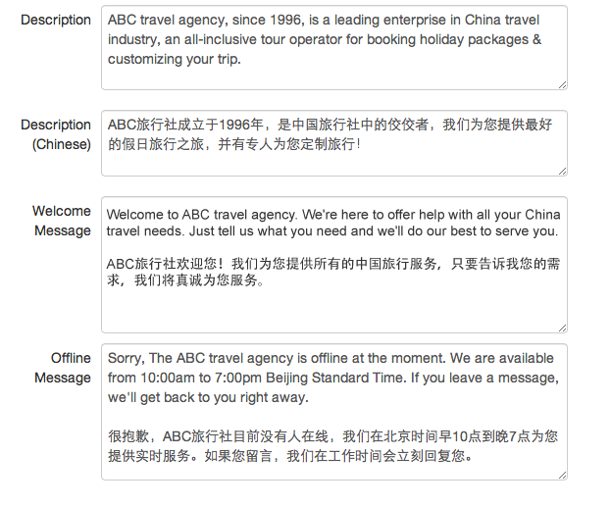
(Figure 2.5: Example description, welcome message, and offline prompts)
Don’t forget to save! Figure 2.6 shows the interface post-save.
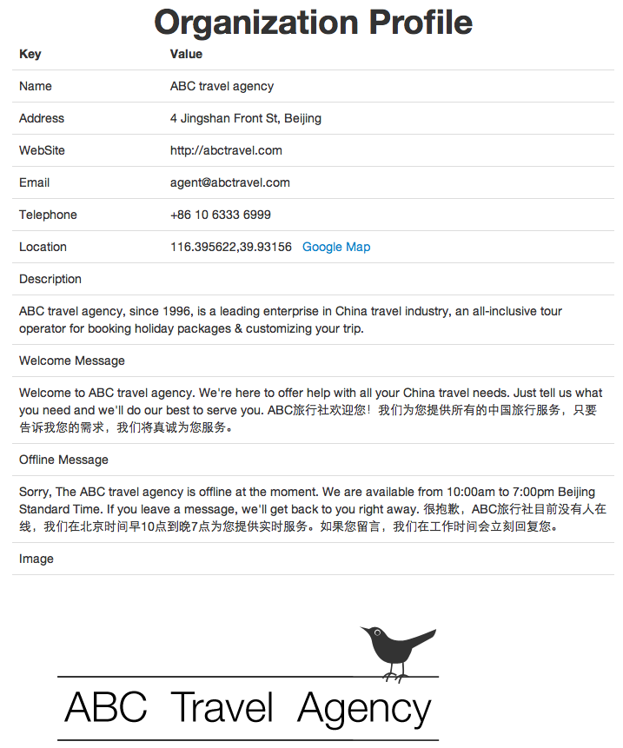
(Figure 2.6: What your information will look like post-save)

3. Fill in the Branches Section

After clicking on Branches in the navigation bar, you should begin adding your company’s branch information. For example, if your company has a branch in New York and in San Francisco, you should add both to the list.

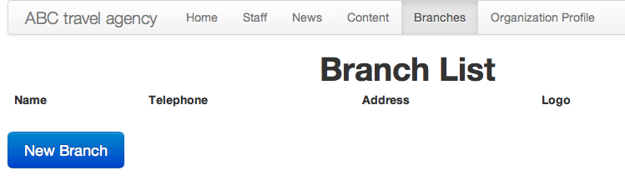
(Figure 3.1: Click on Branches in the navigation bar to add)

After clicking the blue “New Branch” button, add the following information for each branch:
- Name
- Latitude and Longitude
- Address
- Address CN
- Telephone
- Description

After adding branches, you’ll be able to see them in the list, as in Figure 3.2 below

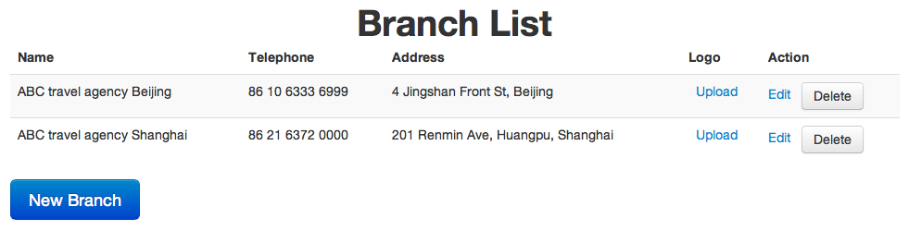
(Figure 3.2: After adding branch information)

If you click the upload button (under logo) next to each branch, you can assign each branch a unique photo. We recommend the image be square in shape and not exceed 180 x 180 pixels.

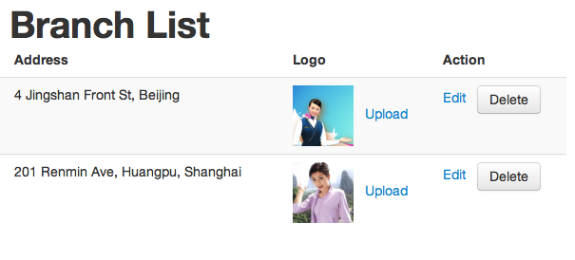
(Figure 3.3: After uploading photos)

After editing the aforementioned information, you’ll be able to see the results immediately on your company’s about section on the Grata mobile application.
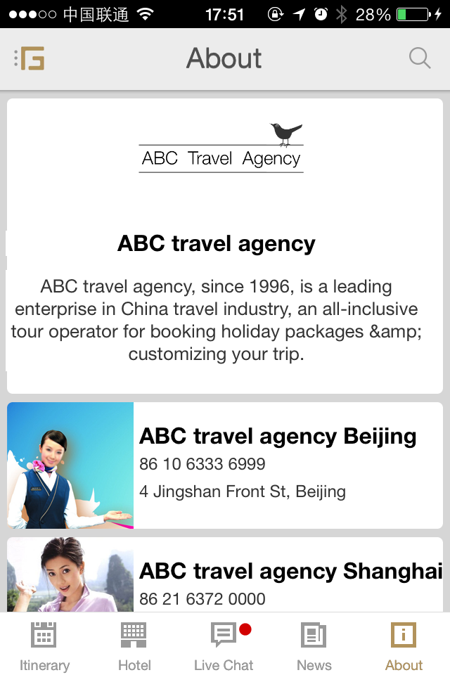
(Figure 3.4: Customers can see branch information for your company on their phones)

4. Creating the Customer Service Section

The content section is a listing of all of your company’s services. Everything you add into the content section will be further divided into two separate sections: a listing and a details sections. The first section constitutes a simple breakdown of what options are provided to your customer for a given service. The second section constitutes the actual information and details pertaining to each option should your customer be interested in them. This breakdown is described in much greater detail below.

Begin by navigating to “Content:”

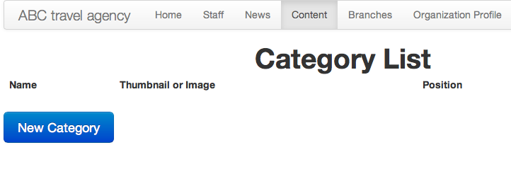
(Figure 4.1: Click on Content in the navigation bar)
In this section, you’ll add any generic services you provide for your customers. In the figures below, ABC travel agency has opted to use guided tours of select places in China.

As you can see below, they’ve decided to add four generic categories under the category list of the content section: classic china tours, Beijing tours, shanghai tours, and gulin tours as in figure 4.2:

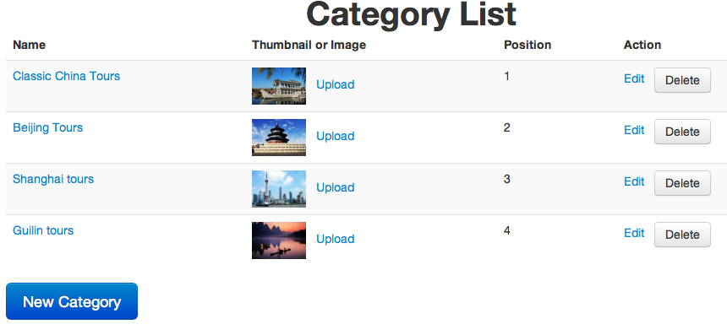
(Figure 4.2: A category list, or section one, with values added)
The idea is that customers can see what generic types of services are being offered by your hotel in this general category list. Should they be interested in one, they simply navigate to that item.

Keeping with this structure, to edit a given tour (or any service you’ve added to the list), for instance Beijing Tours, you’ll be taken to the details page for that service. This second section is where you can add details about the generic service you’ve listed in the previous page. For ABC travel agency, these are things like one-day Beijing Tours, the cost of a one-day Beijing tour, a promotional code, etc.

We recommend you complete the following details section for each detailed listing:
- Code
- Name
- Price
- Unit
- Logo
- Gallery
- Description
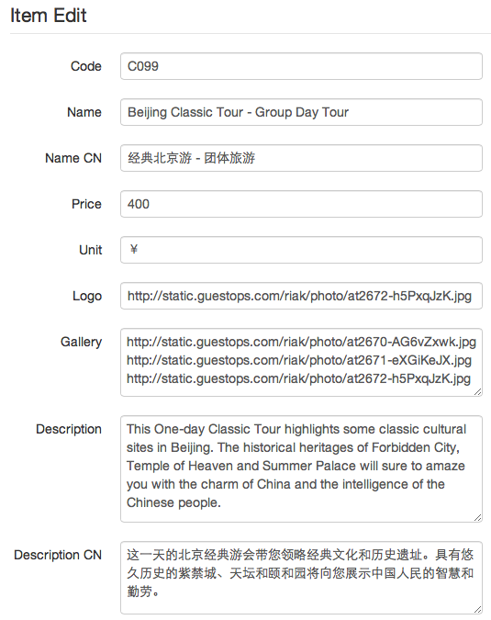
(Figure 4.3: An example of how to fill out the details section)

After filling out section two, you’ll be able to see the added information to each service in the generic services listing (like price).

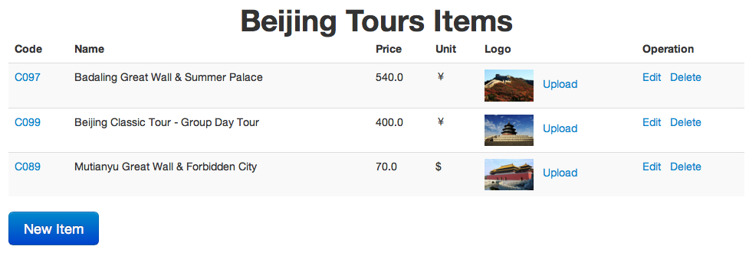
(Figure 4.4: Section two content)

After adding the aforementioned information, you’ll also be able to see the results on your mobile phone.
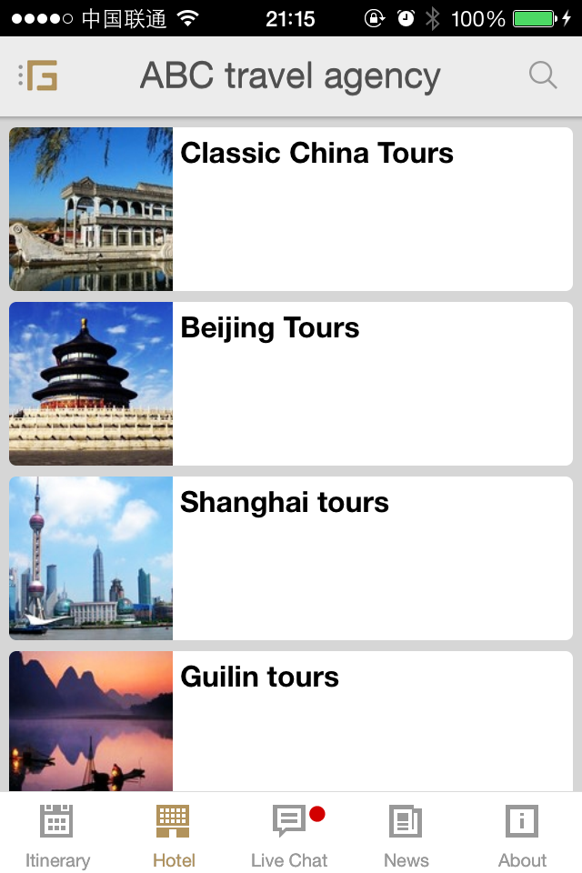
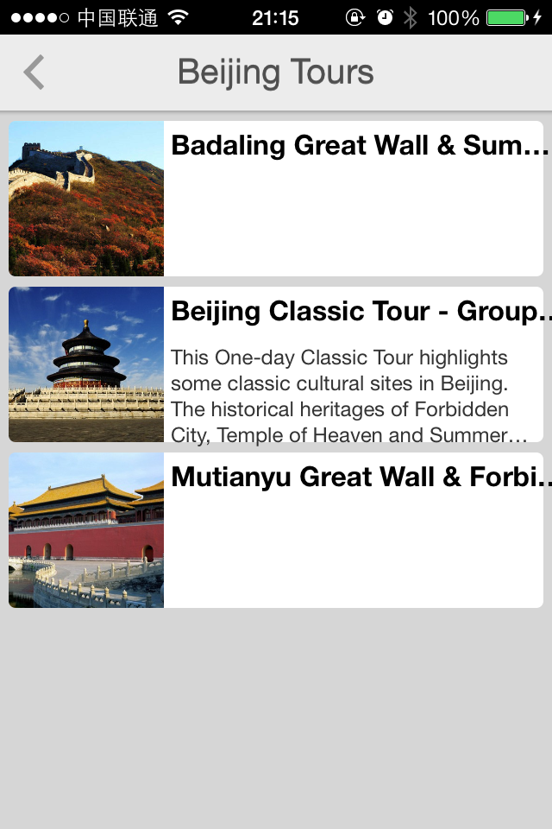
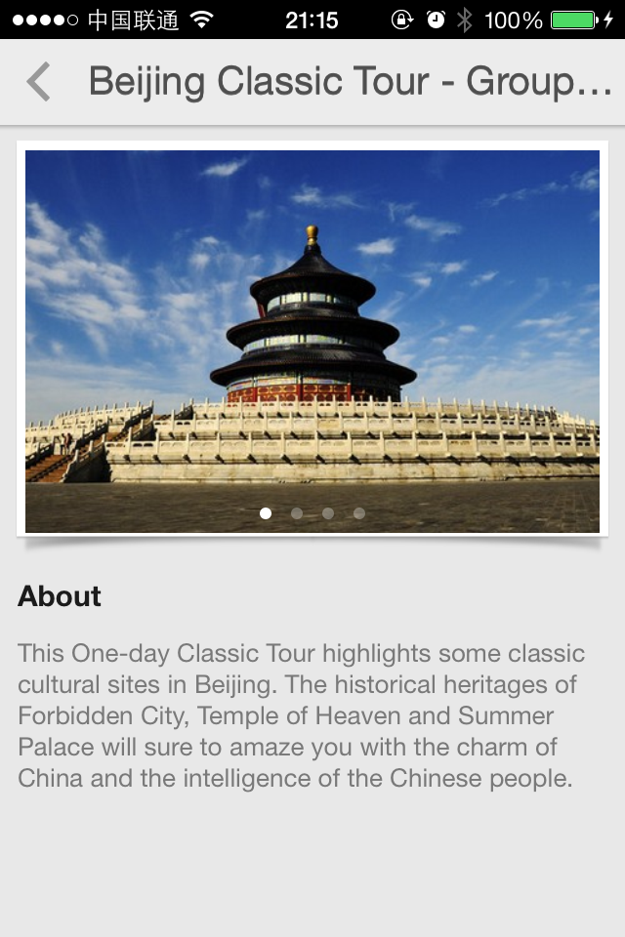
(Figure 4.5: Left slide shows an example service listing, the middle slide shows example detail descriptions)

5. Updating the News section

The news section is your company’s latest news and promotional information. Occasional notifications can let your customers know of new promotional offers and company news.

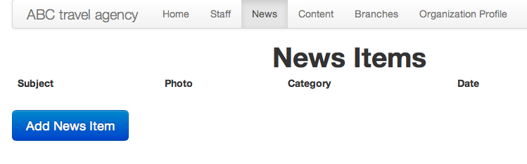
(Figure 5.1: Click News in the navigation bar to begin)
We recommend you fill out the following categories:
- Subject
- Content
- Category

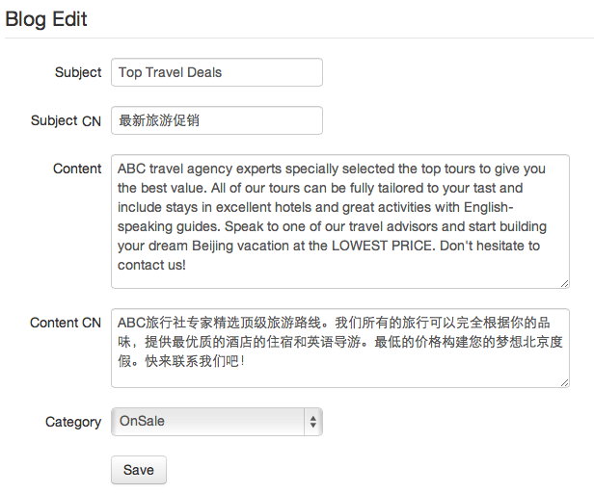
(Figure 5.2: An example news section filled out)

After hitting save, you’ll be able to upload a photo (we recommend no larger than 600 x 600 pixels), and your news section will be complete.

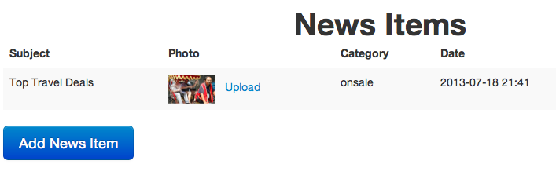
(Figure 5.3: A completed news section)
- Concluding Remarks

Thank you for choosing Grata! The above information describes how to edit your company’s content, if you have any questions please don’t hesitate to contact us. Our contact information is below:
- Website：http://www.grata.com/
- Email：info@grata.com
- Telephone：+86 800.810.0181

Grata, at your service!

